Quantum approach

1. Process: Quantum State Encoding (The "Input" Arrow)
Instead of feeding raw 3D voxels into a CNN, we use a process called Superposition-Based Loading.
- Input: Raw 3D MRI intensities and Clinical MMSE/APOE-ε4 scores.
- Processing (Quantum Feature Mapping): We use a ZZ-Feature Map circuit. This transforms every 3D voxel and every clinical score into a specific "Phase Shift" of a qubit. Because of Superposition, we can represent the entire 128x128x128 MRI volume using only $N$ qubits (where $N = \log_2(\text{voxels})$).
- Output: A single Multimodal Quantum State $|φ|$ that holds the "essence" of the patient’s brain and clinical history simultaneously.

2. Process: Quantum Kernel Estimation (The "Processing" Box)
This is the "Brain" of the system. Instead of "Extracting Features" like a CNN, we calculate the Similarity between patients in a high-dimensional Hilbert Space.
- Input: The Quantum State | $φ$ | of a new patient and the Quantum States of known AD/CN cases.
- Processing (The Quantum Kernel): We run a "Swap Test" circuit. This measures the "overlap" or "distance" between the new patient and the training database. In quantum mechanics, calculating this distance across millions of dimensions happens in constant time O(1), whereas a classical GPU would take O(N) time.
- Output: A Quantum Kernel Matrix (A map of how "similar" this patient is to known Alzheimer's patterns).

3. Process: Quantum-Classical Optimization (The "Decision" Arrow)
- Input: The Kernel Matrix.
- Processing (Quadratic Programming): We use a Quantum Approximate Optimization Algorithm (QAOA). This acts like a super-fast "Sorting Hat." It finds the optimal "Hyperplane" (the boundary) that separates Healthy Brains from Alzheimer's Brains using the distances found in the previous step.
- Output: A Probability Score (e.g., AD: 0.89).

4. Process: Interference-Based Explainability (The "XAI" Box)
- Input: The optimized Quantum Circuit.
- Processing (Circuit Sensitivity Analysis): We measure which qubits (representing specific brain regions like the Hippocampus) caused the most "Quantum Interference." If shifting the Hippocampus qubit changes the diagnosis significantly, it is flagged as the primary cause.
- Output: Probability Heatmaps mapped back to the 3D Brain.

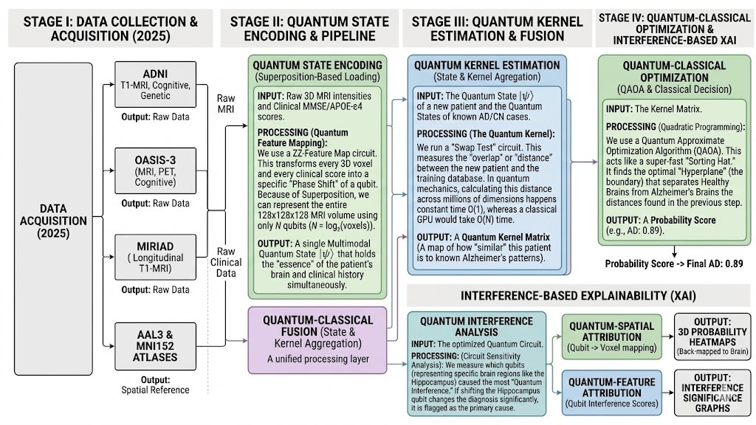

Tools and technologies to be used
Stage | Activity | Qiskit Module / Tool | Purpose
I. Data Encoding | ZZ-Feature Mapping | qiskit.circuit.library.ZZFeatureMap | Transforms normalized 3D MRI voxels and clinical scores into specific phase shifts of qubits using superposition.
 | State Preparation | qiskit.circuit.QuantumCircuit | Manages "Superposition-Based Loading" to represent the entire 3D volume within $N$ qubits.
II. Similarity Analysis | Swap Test Circuit | qiskit.circuit.library.SwapGate | Measures the "overlap" or mathematical distance between a new patient's state and known cases in constant time $O(1)$.
 | Kernel Estimation | qiskit_machine_learning.kernels.QuantumKernel | Aggregates swap test results into a similarity matrix (map of patient patterns).
III. Decision Logic | QAOA Optimizer | qiskit_algorithms.QAOA | Acts as a "Sorting Hat" to find the optimal boundary (hyperplane) that separates healthy brains from AD brains.
 | Quadratic Programming | qiskit_optimization.problems.QuadraticProgram | Formulates the classification as an optimization problem to generate the final diagnostic probability score.
IV. Quantum XAI | Sensitivity Analysis | qiskit.quantum_info | Measures quantum interference and decoherence to identify which specific brain region qubits (like the Hippocampus) drove the decision.
 | Backend Execution | qiskit_aer.AerSimulator | Simulates the quantum circuits on your local CPU/GPU or connects to IBM Quantum hardware for real execution.

Processing pipeline with tools to be used
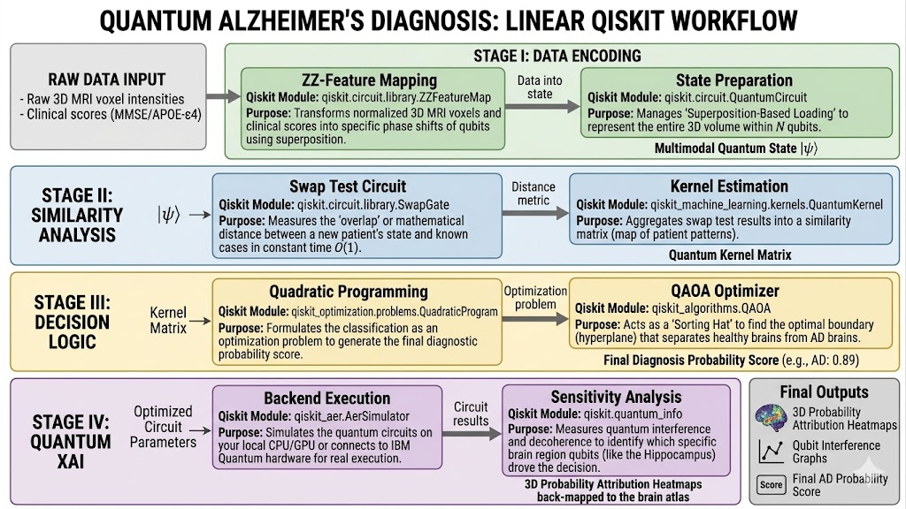

Simplified explanation of all activites
1. State Preparation & Superposition-Based Loading
The Goal: To fit a massive 3D brain scan into a very small number of quantum bits (qubits).
In a normal computer, if you have a 3D image with 2 million points (voxels), you need 2 million slots of memory to hold it. In this quantum activity, we use Superposition. This allows a single qubit to represent multiple values at once. By linking qubits together, the capacity grows exponentially.
How it works: We take the 3D MRI data and clinical scores and "load" them into the quantum system. Because of the math of superposition, we can represent that entire 3D volume using only about 21 linked qubits. This is the stage where the raw data is converted into a "Quantum State" ($|\psi\rangle$).
2. ZZ-Feature Mapping
The Goal: To translate brain features and clinical scores into a language the quantum computer can process.
Quantum computers don't read numbers like "80 years old" or "20% brain shrinkage" directly. They work with the "phase" or the "tilt" of a qubit.
How it works: The ZZ-Feature Map is a specific set of instructions (a circuit) that takes your cleaned data and changes the physical state of the qubits. It "encodes" the data by twisting and rotating the qubits in a high-dimensional space. The "ZZ" part refers to how the qubits interact with each other to capture the relationships between different brain regions—for example, how shrinkage in the Hippocampus relates to a specific memory test score.
3. Swap Test Circuit
The Goal: To instantly compare a new patient to a database of known Alzheimer’s cases.
In classical computing, to see how similar a new patient is to a thousand previous patients, the computer has to compare every single data point one by one. This takes a lot of time and "compute power."
How it works: The Swap Test is a quantum shortcut. It takes two quantum states—the New Patient and a Reference Case—and overlaps them. If they are identical, the quantum interference is perfect; if they are different, the interference changes. The quantum computer can measure this "overlap" (similarity) across all millions of data points simultaneously in a single step.
4. Quantum Kernel Estimation
The Goal: To create a "Similarity Map" of the patient.
The "Kernel" is essentially a table of scores. If the Swap Test tells us how similar a patient is to various known groups (Healthy, Mild Impairment, or Alzheimer's), the Kernel is the collection of those results.
How it works: This process compiles all the individual Swap Test results into a mathematical matrix. Instead of looking for specific "features" like a human doctor might, the system looks at the patient's position in a "Hilbert Space" (a massive, multi-dimensional mathematical territory) to see which diagnostic "neighborhood" they belong to.
5. QAOA (Quantum Approximate Optimization Algorithm)
The Goal: To find the most accurate "boundary line" between health and disease.
Once we have the similarity map, we need to make a final decision. In complex cases, the boundary between "Normal Aging" and "Early Alzheimer's" is very blurry.
How it works: QAOA is an optimization tool. It searches through all possible ways to draw a boundary between the data points to find the one that results in the fewest mistakes. It "tunes" the quantum circuit until the separation between a "Healthy" result and an "Alzheimer's" result is as clear as possible.
6. Quantum Interference Analysis (XAI)
The Goal: To pinpoint exactly which part of the data caused the diagnosis.
This is the "Explainable" part of the AI. We need to know if the AI chose "Alzheimer's" because of the MRI image or because of the MMSE memory score.
How it works: We look at the "Interference" in the circuit. If we slightly wiggle the data for the Hippocampus and the whole diagnostic result changes, we know that specific area was a high-priority factor. If we wiggle the "Gender" data and nothing changes, we know that factor was ignored. This allows us to create the 3D heatmaps that show doctors exactly where the "trouble spots" are in the brain.

Quantum + CNN Hybrid pipeline
Traditional CNN Layer | Quantum CNN Equivalent (QCNN) | Purpose
Input Image | State Preparation | Converting 3D MRI pixels into the "tilt" of qubits.
Convolution Layer | Parameterized Unitary (U) | A set of quantum gates that act on a "local patch" of qubits to find patterns (like edges or brain atrophy).
Pooling Layer | Quantum Measurement | Measuring a few qubits and using the result to "compress" the data, reducing the system size.
Fully Connected Layer | Final Rotation & Measurement | A final quantum circuit that collapses the information into a single "Yes/No" diagnosis.

How the Training Pipeline Works :
- Forward Pass (Quantum): The 3D MRI data goes in.
- It passes through the quantum "Convolution" gates.
- The final measurement gives a prediction (e.g., "0.82 probability of Alzheimer's").
- Loss Calculation (Classical): Your computer compares that 0.82 to the actual CDR label (the "Answer Key").
- It calculates the error (Loss), just like in a standard CNN.
- Backpropagation (Hybrid): This is the clever part. You use the Parameter Shift Rule.
- The computer slightly tweaks the "angles" of the quantum gates (the weights) to see if the error goes down.
- It uses a classical optimizer to update the quantum circuit for the next round.
- Repeat: You run this for 10, 50, or 100 epochs until the quantum gates have "learned" the signature of Alzheimer's.

